Cairo University Faculty of Computers and Information



**CS352 – Software Engineering II**

**Phase 2-a Template**

**2015**

**Project Team**

|  |  |  |  |
| --- | --- | --- | --- |
| **ID** | **Name** | **Email** | **Mobile** |
| 20120364 | Mahmoud Mohamed Hadad | m.hadad@stud.fci-cu.edu.eg | 01117943793 |
| 20120062 | Ahmed Mohammed Fekry | ahmedfikry78@gmail.com | 01112059041 |
| 20120084 | Eslam Ebrahim Mohamed | altaiir_brotherhood@yahoo.com | 01141731202 |
| 20120207 | Sherif Mohamed Farouk | sfarouk513@gmail.com | 01144967048 |

**Staff: Dr Mohammad El-Ramly m.elramly@fci-cu.edu.eg**

**TAs: Eng Mohamed Samir m.samir@fci-cu.edu.eg**

**Eng Desoky Abd El-qawy d.abdelqawy@fci-cu.edu.eg**

Contents

Your Restful API 3

Class diagram design 4

Daily scrum Meetings 5

Trello workspace screenshot 5

Github repository link 6

# 

# Your Restful API

|  |  |
| --- | --- |
| **Service name** | **login** |
| **Input type** | **POST** |
| **Service URL** | **localhost:8888/social/login/** |
| **Parameters** | |  |  | | --- | --- | | **NAME** | **Description** | | **username** | **username that used to login** | | **password** | **the user's password** | |
| **Example request** | **POST**  **http://localhost:8888/rest/ login? username =** **eslam& password =123** |
| **Example response** | **{"id":1,"Status":"OK", name":" eslam ","password":"123"}** |

|  |  |
| --- | --- |
| **Service name** | **signout** |
| **Input type** | **POST** |
| **Service URL** | **localhost:8888/social/signout/** |
| **Parameters** | **No parameters** |
| **Example request** | **POST**  **http://localhost:8888/rest/ signout** |
| **Example response** | **{"id":1,"Status":"OK", name":" eslam ","password":"123"}** |

|  |  |
| --- | --- |
| **Service name** | **FriendRequest** |
| **Input type** | **POST** |
| **Service URL** | http://localhost:8888/social/FriendRequest |
| **Parameters** | |  |  | | --- | --- | | **NAME** | **Description** | | **senderUser** | **Sender username** | | **friendUser** | **Username of the receiver** | | **senderPassword** | **Password of sender** | |
| **Example request** | http://localhost:8888/social/FriendRequest? **senderUser=hadad& friendUser=sherif& senderPassword=123** |
| **Example response** | **{“Status”:”OK”}** |

|  |  |
| --- | --- |
| **Service name** | **AddFriend** |
| **Input type** | **POST** |
| **Service URL** | http://localhost:8888/social/AddFriend |
| **Parameters** | |  |  | | --- | --- | | **NAME** | **Description** | | **senderUser** | **Username of request sender** | | **friendUser** | **Username of the request receiver** | | **senderPassword** | **Password of request receiver (who accepts the request)** | |
| **Example request** | http://localhost:8888/rest/AddFriend **senderUser=hadad& friendUser=sherif& senderPassword=123** |
| **Example response** | **{“Status”:”Failed”}** |

|  |  |
| --- | --- |
| **Service name** | **FriendRequestService** |
| **Input type** | **POST** |
| **Service URL** | http://localhost:8888/rest/**FriendRequestService** |
| **Parameters** | |  |  | | --- | --- | | **NAME** | **Description** | | **senderUser** | **Sender username** | | **friendUser** | **Username of the receiver** | | **senderPassword** | **Password of sender** | |
| **Example request** | http://localhost:8888/rest/**FriendRequestService**? **senderUser=hadad& friendUser=sherif& senderPassword=123** |
| **Example response** | **{“Status”:”OK”}** |

|  |  |
| --- | --- |
| **Service name** | **AddFriendService** |
| **Input type** | **POST** |
| **Service URL** | http://localhost:8888/rest/AddFriendService |
| **Parameters** | |  |  | | --- | --- | | **NAME** | **Description** | | **senderUser** | **Username of request sender** | | **friendUser** | **Username of the request receiver** | | **senderPassword** | **Password of request receiver (who accepts the request)** | |
| **Example request** | http://localhost:8888/rest/AddFriendService **senderUser=hadad& friendUser=sherif& senderPassword=123** |
| **Example response** | **{“Status”:”OK”}** |

# Class diagram design

* **You should provide clean version for your class diagram design.**
* **Class diagram is a static diagram and should not represent any dynamic flow of events.**
* **Put Relationships between classes and the types of the relationships.**
* **Put multiplicity.**
* **Put relationship name (e.g. faculty "offer" course).**
* **Put attributes in the classes.**
* **Put functions & Put parameters.**
* **Put data types of each attributes and the parameters.**
* **Highly perfered: Each class has a corresponding interface**
  + **Let all objects parameters and returns be of interface type.**
* **See Shopping Cart Case Study**

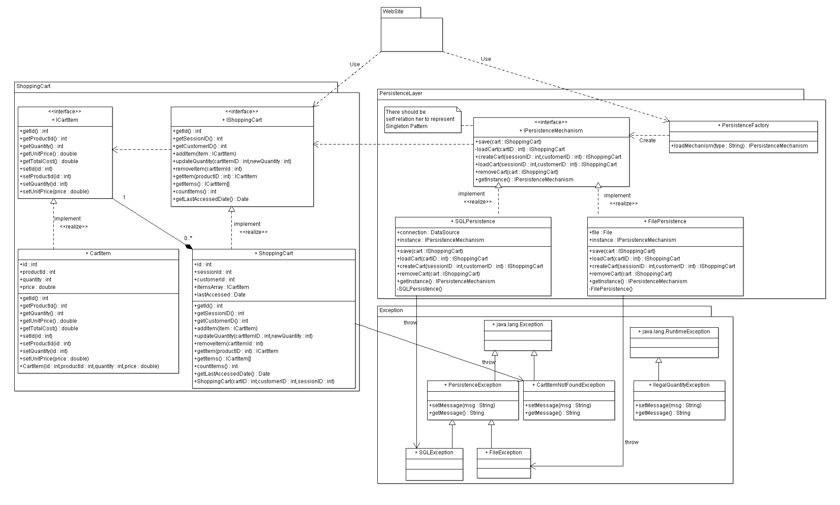

# 

# Trello workspace screenshot

# 

# Github repository link

* **https://github.com/ahmedfekry/FCI-CS352-MASE**